LAB EXPERIMENT RECORD
Set 7: Customer Demographics Analysis
Department | AIDS
Course Code / Course Name | DSA0602 / Data Handling and Visualization
Experiment | Data Visualization using R and Tableau
Name | Vemula Jaswanth
Register Number | 192424231
Date | 3 October 2026
Day | Saturday

Aim
To visualize customer demographic data using a bar chart, pie chart, and data table in R, and to build an interactive dashboard in Tableau.

Dataset: Customer Demographics
Customer ID | Age | Gender | Income (in $)
1 | 28 | Female | 50000
2 | 35 | Male | 60000
3 | 42 | Female | 75000

PROGRAM 1: Bar Chart of Customer Ages
Create a bar chart to visualize the distribution of customer ages. Label the axes and title the chart.
# Dataset customer_id <- c(1, 2, 3) age <- c(28, 35, 42)
# Bar Chart barplot(age, names.arg = customer_id, xlab = "Customer ID", ylab = "Age (years)", main = "Distribution of Customer Ages", col = "skyblue", ylim = c(0, 50))
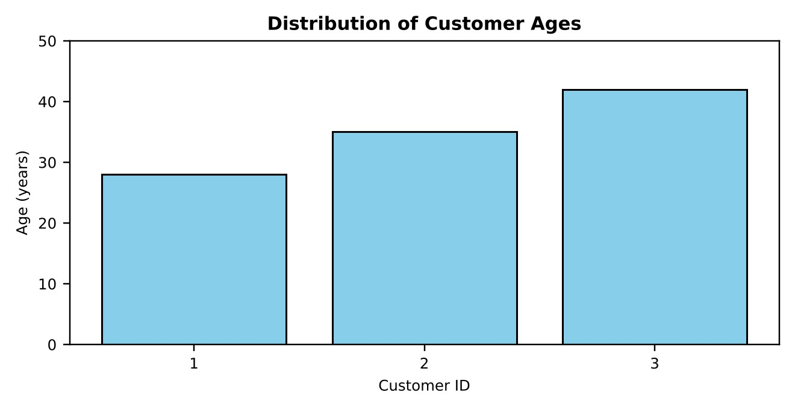

Output 1: Distribution of Customer Ages Bar Chart
Observation: Customer 3 is the oldest (42 years) and Customer 1 is the youngest (28 years).
Customer 2 is 35 years old, so the ages increase steadily with the customer ID and the average age is 35 years.

PROGRAM 2: Pie Chart of Customers by Gender
Generate a pie chart to represent the distribution of customers by gender.
# Dataset gender <- c("Female", "Male", "Female")
# Count and percentage of each gender gender_count <- table(gender) percent <- round(gender_count / sum(gender_count) * 100, 1) labels <- paste0(names(gender_count), " (", percent, "%)")
# Pie Chart pie(gender_count, labels = labels, col = c("pink", "skyblue"),
main = "Distribution of Customers by Gender")
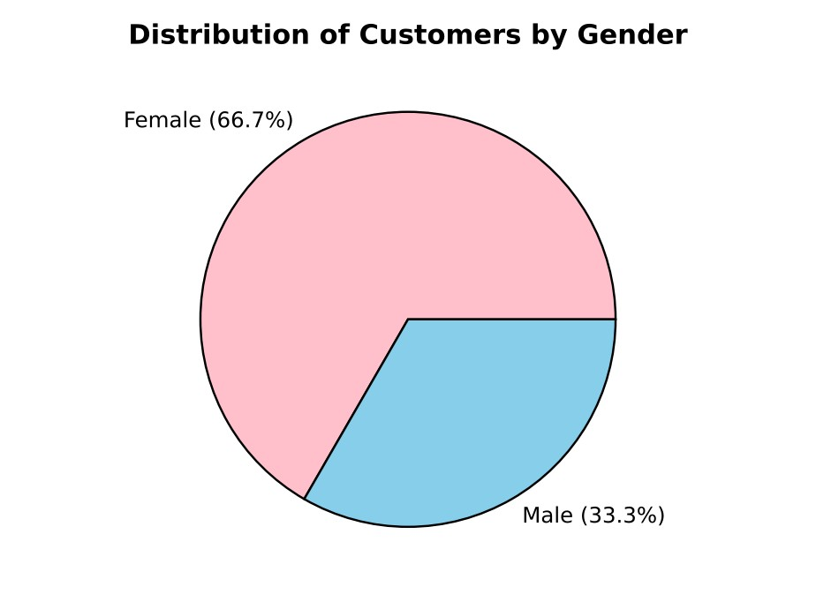

Output 2: Distribution of Customers by Gender (Pie Chart)
Observation: Female customers form the larger share with 2 of the 3 customers (66.7%), while male customers make up the remaining 1 customer (33.3%).

PROGRAM 3: Table of Demographic Information
Build a table to show the demographic information for each customer. Label the table elements.
# Dataset
customers <- data.frame( Customer_ID = c(1, 2, 3),
Age = c(28, 35, 42),
Gender = c("Female", "Male", "Female"),
Income = c(50000, 60000, 75000))
# Label the table elements colnames(customers) <- c("Customer ID", "Age", "Gender", "Income (in $)")
# Display the table print(customers)
# Average age and average income mean(customers$Age) mean(customers$Income)
Customer ID | Age | Gender | Income (in $)
1 | 28 | Female | 50000
2 | 35 | Male | 60000
3 | 42 | Female | 75000

Output 3: Customer Demographics Table
Observation: The table lists the age, gender, and income of each customer. The average age is 35 years and the average income is $61,666.67. Income rises with age: $50,000 at age 28, $60,000 at age 35, and $75,000 at age 42.

PROGRAM 4: Tableau Dashboard for Customer Demographics
Develop a Tableau dashboard combining the bar chart, pie chart, and table for interactive exploration of customer demographics.
Steps in Tableau:
- Save the customer data as an Excel or CSV file with the columns Customer ID, Age, Gender, andIncome.
- Open Tableau, choose Connect > Microsoft Excel / Text file, and load the file. Right-clickCustomer ID and choose Convert to Dimension so that the IDs are not summed.
- Sheet 1 (Bar Chart): drag Customer ID to Columns and Age to Rows (SUM). Choose the Bar marktype and title the sheet "Customer Ages".
- Sheet 2 (Pie Chart): choose the Pie mark type, drag Gender to Color and Number of Records to
Angle. Drag Number of Records to Label and apply Quick Table Calculation > Percent of Total. Title the sheet "Gender Distribution".
- Sheet 3 (Table): drag Customer ID and Gender to Rows, then drag Measure Names to Columnsand Measure Values (Age, Income) to Text. Title the sheet "Customer Details".
- Create a new Dashboard, drag all three sheets onto it, and arrange the bar chart and pie chart at thetop and the table at the bottom.
- For interactivity, select "Use as Filter" on the bar chart and pie chart and add a Gender filter (ShowFilter), so that every view updates together.
- Title the dashboard "Customer Demographics Dashboard" and save the workbook.
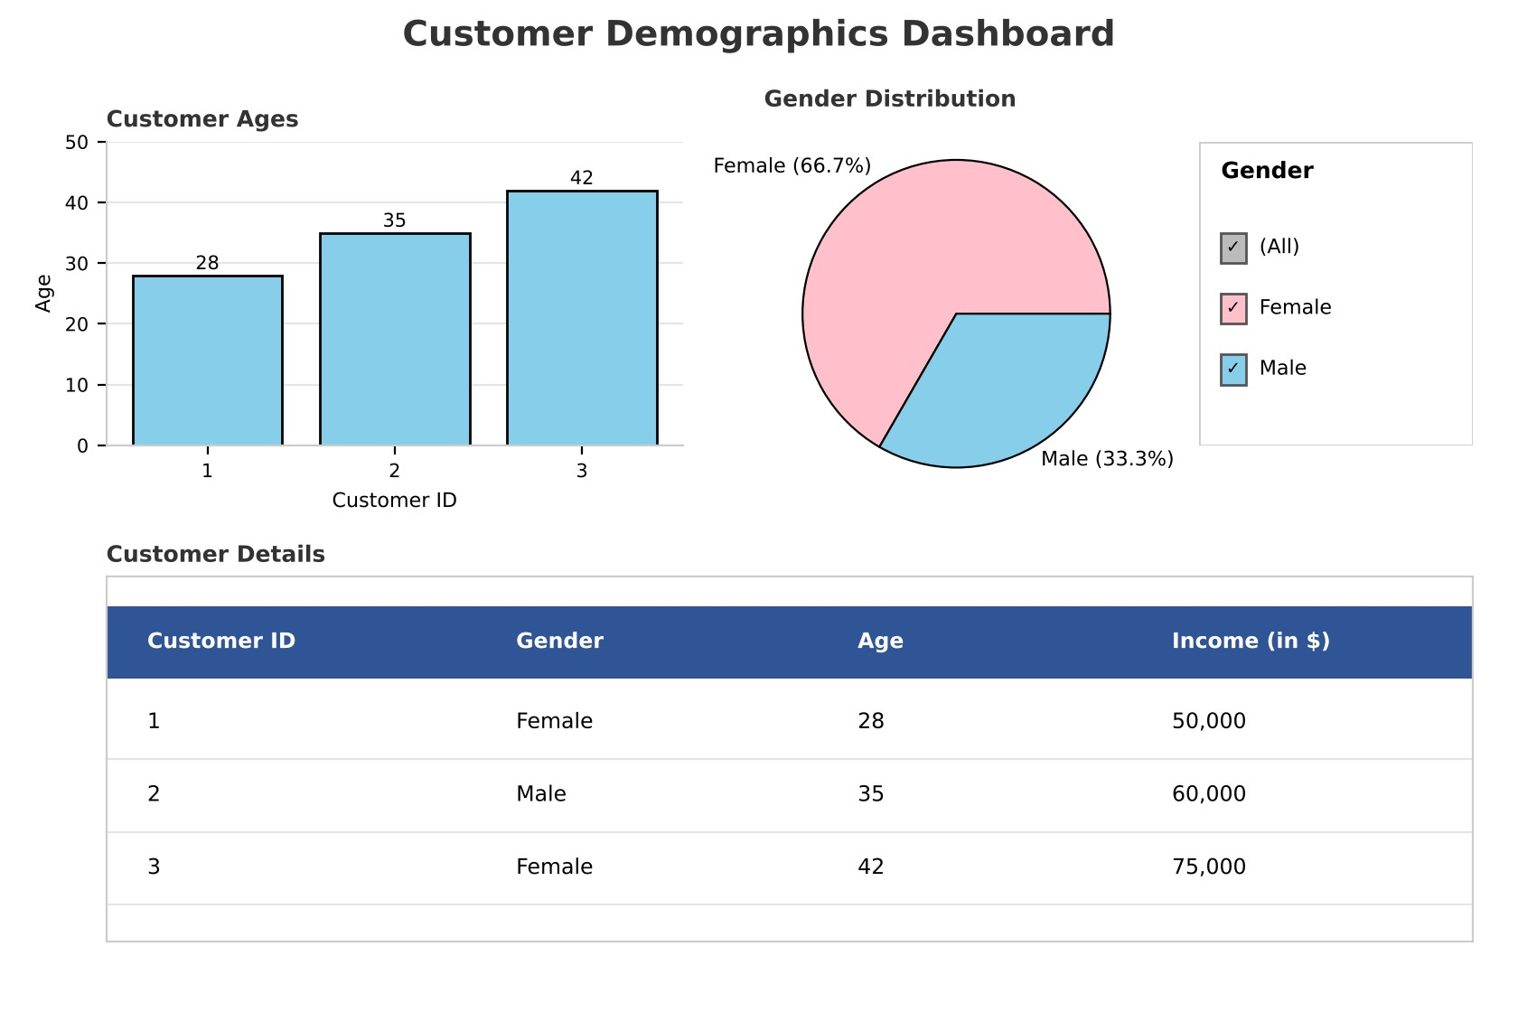

Output 4: Customer Demographics Tableau Dashboard
Observation: The dashboard shows the customer ages, the gender split, and the detailed table together. Clicking a bar, a pie slice, or the Gender filter updates all three views, so users can explore the demographics interactively.

Set 7 Procedure
- Create vectors for the customer ID, age, gender, and income.
- Use barplot() to display the age of each customer.
- Use table() to count the genders and pie() to draw the gender distribution.
- Build a data frame with data.frame(), label the columns with colnames(), and display it with print().
- Connect the dataset in Tableau, build the bar chart, pie chart, and table sheets, and combine them ina dashboard with filters.

Set 7 Result
The customer demographic data was successfully visualized using a bar chart, pie chart, and data table in R. A Tableau dashboard combining all three views was created for interactive exploration.

Key Functions Used
Function / Tool | Purpose
barplot() | Creates the bar chart of customer ages.
table() | Counts the customers in each gender.
pie() | Creates the pie chart of the gender distribution.
data.frame() / print() | Builds and displays the demographic table.
Tableau Dashboard | Combines sheets with filters for interactive exploration.

SET 8: EMPLOYEE PERFORMANCE ANALYSIS

Aim
To analyse employee performance data using a line chart, bar chart, and data table in R, and to build an interactive dashboard in Tableau.

Dataset: Employee Performance
Employee ID | Department | Years of Service | Performance Score
1 | Sales | 5 | 85
2 | HR | 3 | 92
3 | Marketing | 7 | 78
Note: The dataset does not contain a date column, so Years of Service is used as the time axis for the performance trend in Program 1.

PROGRAM 1: Line Chart of Performance Trend
Create a line chart to visualize the performance trend of employees over time. Label the axes and title the chart.
# Dataset
employee <- data.frame( Employee_ID = c(1, 2, 3),
Department = c("Sales", "HR", "Marketing"),
Years_of_Service = c(5, 3, 7),
Performance_Score = c(85, 92, 78))
# Arrange the employees by years of service (time axis) trend <- employee[order(employee$Years_of_Service), ]
# Line Chart plot(trend$Years_of_Service, trend$Performance_Score, type = "o", xlab = "Years of Service", ylab = "Performance Score", main = "Performance Trend by Years of Service", col = "blue", xaxt = "n", ylim = c(70, 100)) axis(1, at = trend$Years_of_Service)
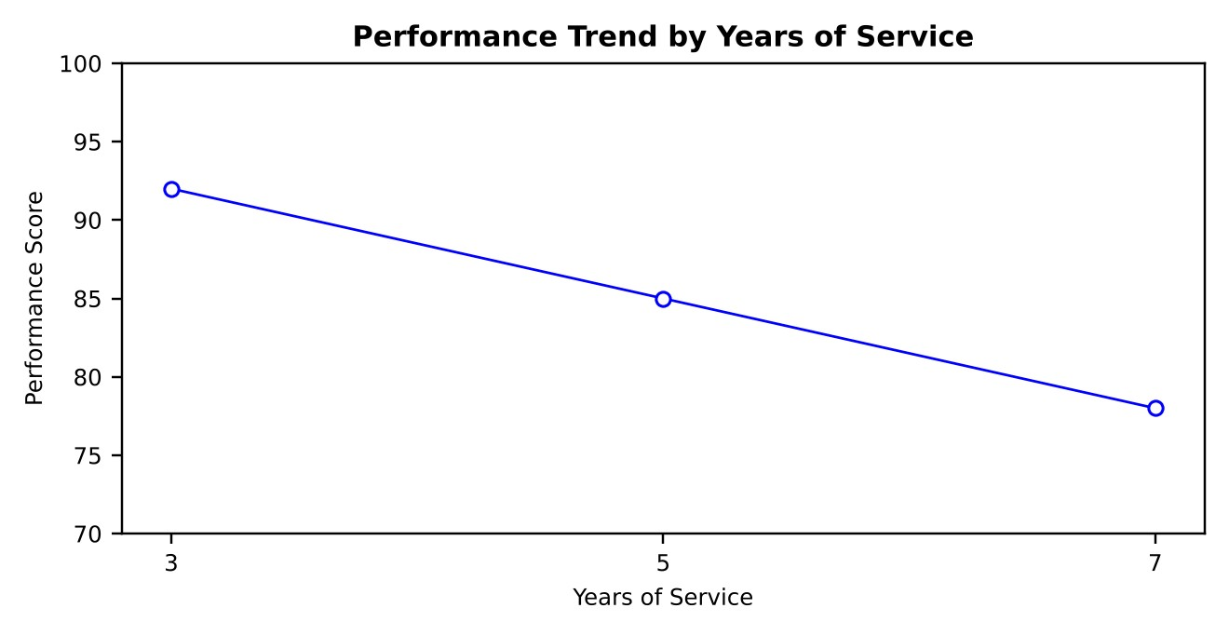

Output 1: Performance Trend Line Chart
Observation: The performance score falls from 92 at 3 years of service to 85 at 5 years and 78 at 7 years. The score drops by 7 points for every 2 additional years, giving a steady downward trend.

PROGRAM 2: Bar Chart of Performance by Department
Generate a bar chart showing the distribution of employees across different departments. Label the chart elements.
# Bar Chart barplot(employee$Performance_Score, names.arg = employee$Department, xlab = "Department", ylab = "Performance Score", main = "Performance Score by Department", col = c("skyblue", "lightgreen", "orange"), ylim = c(0, 100))
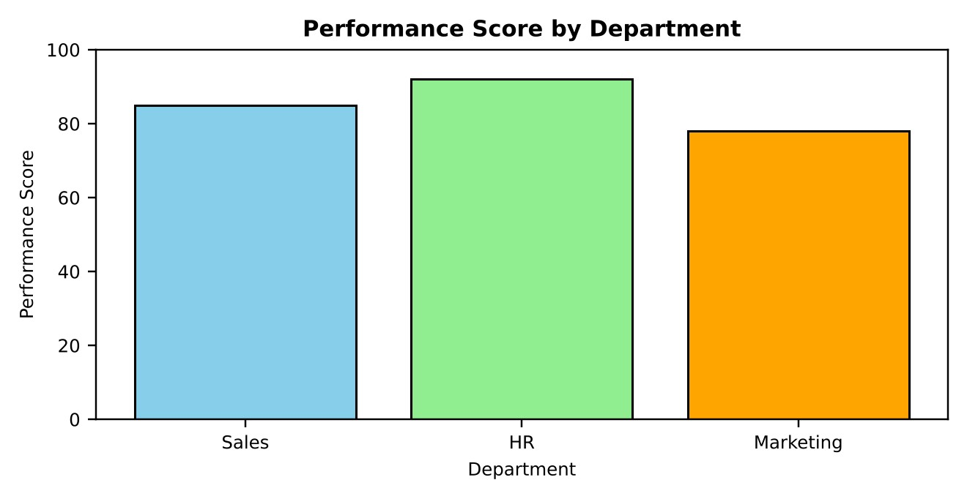

Output 2: Performance Score by Department (Bar Chart)
Observation: The HR employee has the highest performance score (92), followed by Sales (85).
Marketing has the lowest score (78). Each department has exactly one employee in this dataset.

PROGRAM 3: Table of Performance Data
Build a table to show the performance data for each employee. Label the table elements.
# Add a rating based on the performance score employee$Rating <- ifelse(employee$Performance_Score >= 90, "Excellent", ifelse(employee$Performance_Score >= 80, "Good", "Average"))
# Label the table elements colnames(employee) <- c("Employee ID", "Department", "Years of Service", "Performance Score", "Rating")
# Display the table print(employee)
Employee ID | Department | Years of Service | Performance  Score | Rating
1 | Sales | 5 | 85 | Good
2 | HR | 3 | 92 | Excellent
3 | Marketing | 7 | 78 | Average

Output 3: Employee Performance Table
Observation: The table lists the department, years of service, and performance score of each employee with a rating (90 and above = Excellent, 80 to 89 = Good, below 80 = Average). The average performance score is 85.

PROGRAM 4: Tableau Dashboard for Employee Performance
Develop a Tableau dashboard combining the line chart, bar chart, and table for interactive exploration of employee performance data.
Steps in Tableau:
- Save the employee data as an Excel or CSV file with the columns Employee ID, Department,Years of Service, and Performance Score.
- Open Tableau, connect to the file, and load the data. Right-click Employee ID and choose Convertto Dimension.
- Sheet 1 (Line Chart): drag Years of Service to Columns (discrete) and Performance Score to Rows(SUM). Choose the Line mark type and title the sheet "Performance Trend".
- Sheet 2 (Bar Chart): drag Department to Columns and Performance Score to Rows (SUM). Choosethe Bar mark type, drag Department to Color, and title the sheet "Performance by Department".
- Sheet 3 (Table): drag Employee ID and Department to Rows, then drag Measure Names to
Columns and Measure Values (Years of Service, Performance Score) to Text. Title the sheet "Employee Details".
- Create a new Dashboard, drag all three sheets onto it, and arrange the two charts at the top and thetable at the bottom.
- For interactivity, select "Use as Filter" on the charts and add a Department filter (Show Filter) soevery view updates together.
- Title the dashboard "Employee Performance Dashboard" and save the workbook.
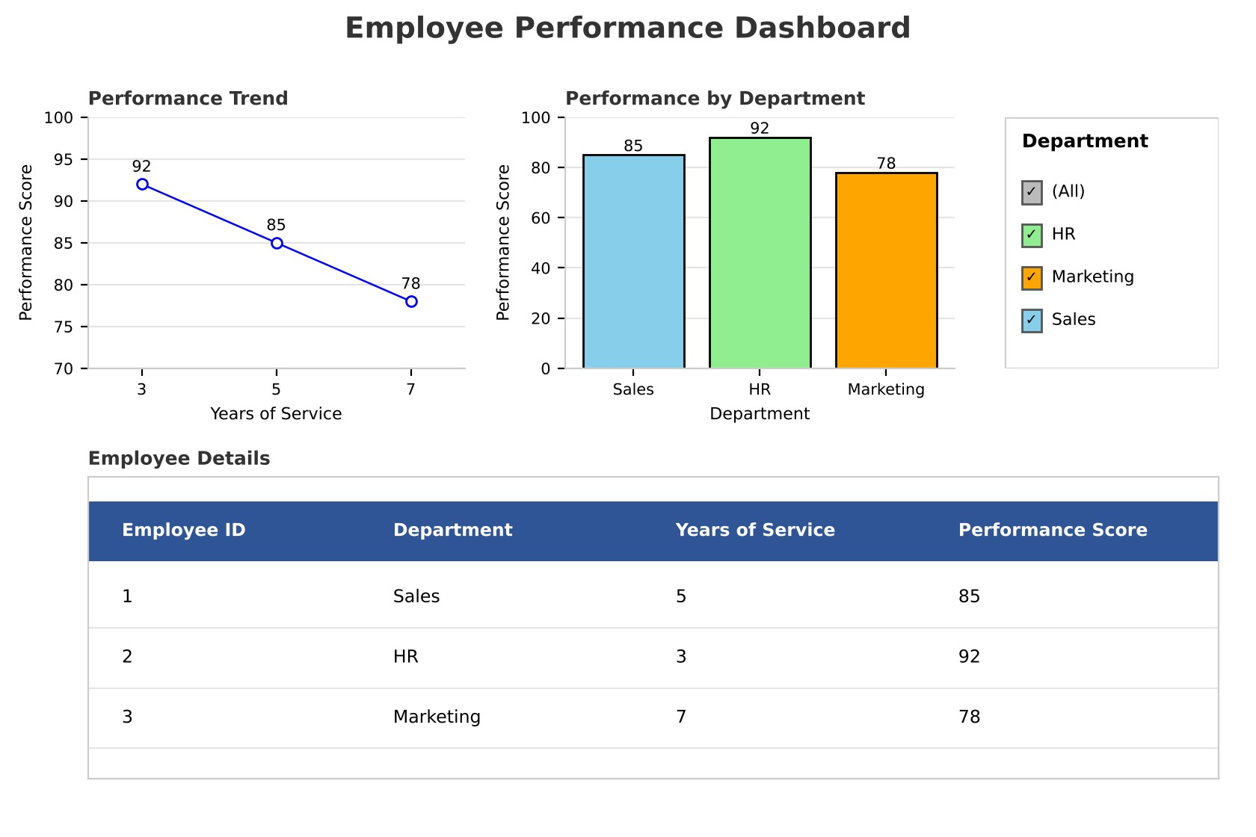

Output 4: Employee Performance Tableau Dashboard
Observation: The dashboard shows the performance trend, the department comparison, and the detailed table together. Selecting a department or a bar filters all three views, so users can explore employee performance interactively.

Set 8 Procedure
- Create a data frame with the employee ID, department, years of service, and performance score.
- Sort the data with order() and use plot() with type = "o" to draw the performance trend line chart.
- Use barplot() to display the performance score of each department.
- Add a rating with ifelse(), label the columns with colnames(), and display the table with print().
- Connect the dataset in Tableau, build the line chart, bar chart, and table sheets, and combine themin a dashboard with filters.

Set 8 Result
The employee performance data was successfully visualized using a line chart, bar chart, and data table in R. A Tableau dashboard combining all three views was created for interactive exploration.

Key Functions Used
Function / Tool | Purpose
order() | Sorts the employees by years of service.
plot() | Creates the line chart of the performance trend.
barplot() | Creates the bar chart of performance by department.
ifelse() | Assigns a performance rating to each score.
data.frame() / print() | Builds and displays the performance table.
Tableau Dashboard | Combines sheets with filters for interactive exploration.

SET 9: ONLINE LEARNING ACTIVITY

Aim
To analyse online learning activity data using a histogram, boxplot, bubble scatter plot, and monthly trend line in R, and to build an interactive dashboard in Tableau.

Dataset: Online_Learning_Activity.csv
Student_ID | Gender | Age | Course | Study_Time  (hrs) | Videos_Watched | Quiz_Score | Login_Date
L01 | Male | 20 | R | 3.5 | 12 | 78 | 2025-01-05
L02 | Female | 22 | R | 4.2 | 15 | 85 | 2025-01-05
L03 | Male | 19 | SQL | 2.0 | 8 | 65 | 2025-02-08
L04 | Female | 21 | R | 5.0 | 18 | 92 | 2025-02-08
L05 | Male | 23 | R | 2.5 | 9 | 70 | 2025-03-12
L06 | Female | 20 | SQL | 4.0 | 14 | 88 | 2025-03-12

PROGRAM 1: Histogram and Boxplot of Quiz Score
Import the dataset in R. Plot a histogram for Quiz_Score. Draw a boxplot of Quiz_Score by Course.
Add title and labels. Interpret student performance.
# Import the dataset learning <- read.csv("Online_Learning_Activity.csv")
# Histogram of Quiz_Score hist(learning$Quiz_Score, breaks = seq(60, 100, by = 10), main = "Histogram of Quiz Score", xlab = "Quiz Score", ylab = "Frequency", col = "skyblue")
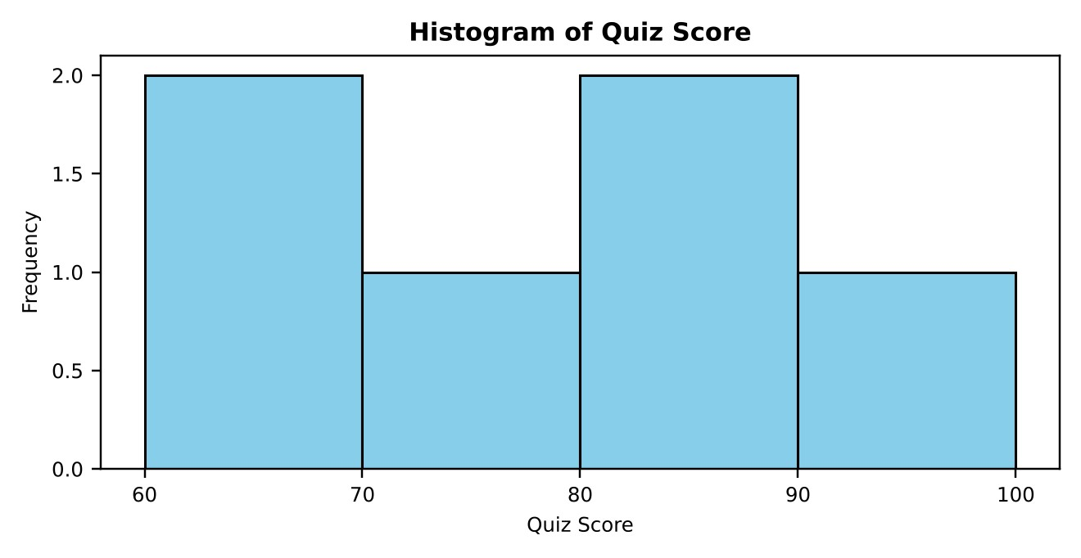

Output 1: Histogram of Quiz Score
# Boxplot of Quiz_Score by Course boxplot(Quiz_Score ~ Course, data = learning, main = "Quiz Score by Course", xlab = "Course", ylab = "Quiz Score", col = c("skyblue", "lightgreen"))
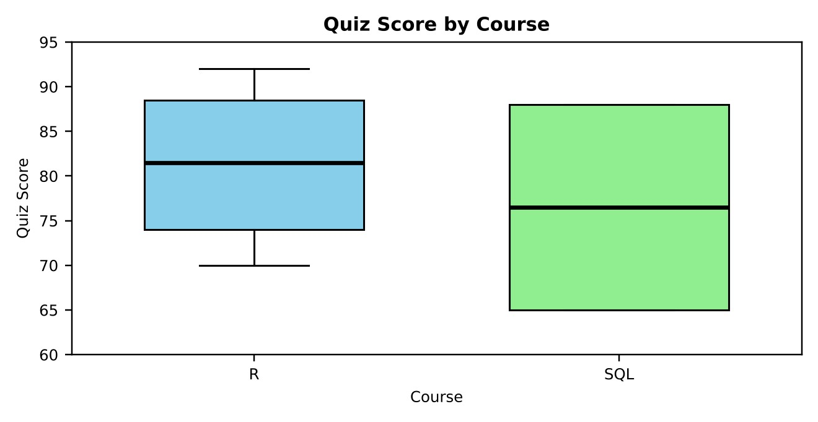

Output 2: Boxplot of Quiz Score by Course
Interpretation: The quiz scores range from 65 to 92, with a mean of 79.7 and a median of 81.5. The histogram has two peaks, at 60-70 and at 80-90 (two students each), so the class splits into a lower-scoring and a higher-scoring group. In the boxplot, R has the higher median (81.5) and the highest score (92), while SQL has a lower median (76.5) and a wider spread (65 to 88). Only two students took SQL, so this comparison is an indication rather than a firm conclusion.

PROGRAM 2: Bubble Scatter Plot of Study Time vs Quiz Score
Create a scatter plot using R programming between Study_Time and Quiz_Score. Represent Videos_Watched using bubble size. Apply transparency. Explain the learning pattern.
library(ggplot2)
# Bubble chart: bubble size = Videos_Watched, transparency = 0.6 ggplot(learning, aes(x = Study_Time, y = Quiz_Score, size = Videos_Watched)) + geom_point(alpha = 0.6, colour = "steelblue") + scale_size(range = c(4, 14)) + labs(title = "Study Time vs Quiz Score (bubble size = Videos Watched)", x = "Study Time (hrs)", y = "Quiz Score", size = "Videos_Watched")
# Strength of the relationship
cor(learning$Study_Time, learning$Quiz_Score)
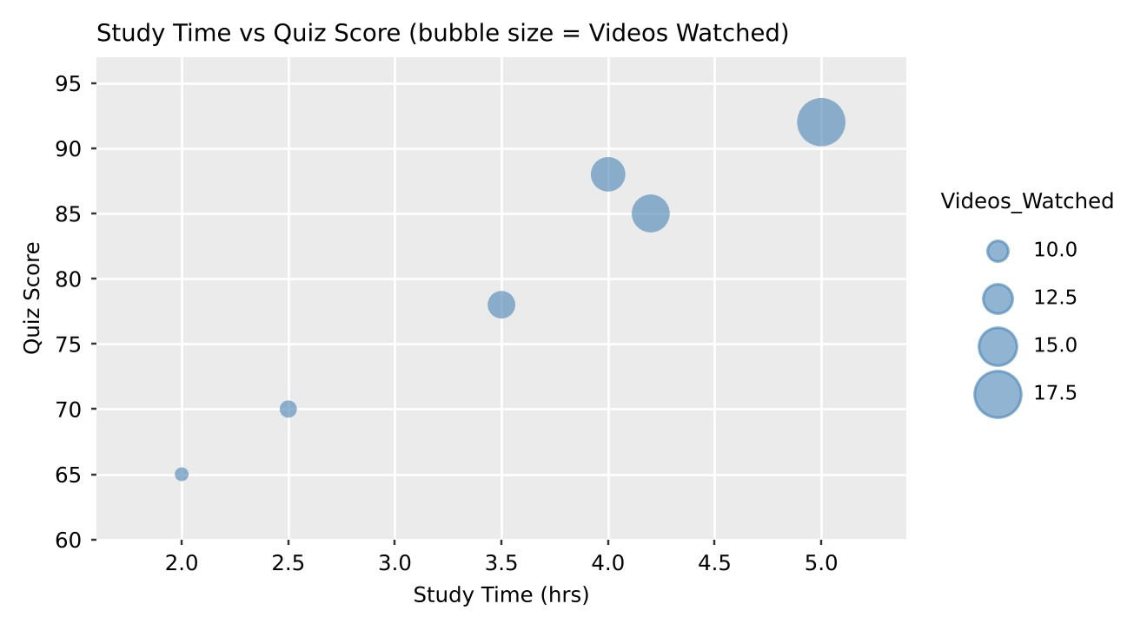

Output 3: Study Time vs Quiz Score Bubble Plot
Learning pattern: The points rise from the lower left to the upper right, and the correlation coefficient is about 0.98, a very strong positive relationship. Students who study longer also score higher. The bubbles also grow larger toward the top right: L04 studied 5.0 hours, watched 18 videos, and scored 92, while L03 studied 2.0 hours, watched 8 videos, and scored 65. So more study time and more videos watched go together with better quiz scores. With only six students this shows a pattern but does not prove cause.

PROGRAM 3: Monthly Average Quiz Score with Moving Average
Using R programming, convert Login_Date into Date format. Calculate the average quiz score per month. Plot a line chart. Apply moving average smoothing. Identify the trend.
# Convert Login_Date to Date format and extract the month learning$Login_Date <- as.Date(learning$Login_Date, format = "%Y-%m-%d") learning$Month <- format(learning$Login_Date, "%Y-%m")
# Average quiz score per month monthly <- aggregate(Quiz_Score ~ Month, data = learning, FUN = mean)
# 2-month moving average (smoothing) monthly$Moving_Avg <- as.numeric(stats::filter(monthly$Quiz_Score, rep(1/2, 2), sides = 1)) print(monthly)
# Line chart with the moving average plot(1:3, monthly$Quiz_Score, type = "o", col = "blue", xaxt = "n", xlab = "Month", ylab = "Average Quiz Score", main = "Average Quiz Score per Month", ylim = c(76, 84)) axis(1, at = 1:3, labels = monthly$Month) lines(1:3, monthly$Moving_Avg, type = "o", col = "red", lty = 2, pch = 15) legend("topright", legend = c("Monthly average", "2-month moving average"), col = c("blue", "red"), lty = c(1, 2), pch = c(1, 15))
Month | Quiz_Score (Average) | Moving_Avg
2025-01 | 81.50 | NA
2025-02 | 78.50 | 80.00
2025-03 | 79.00 | 78.75
Output 4: Monthly Average Quiz Score Table
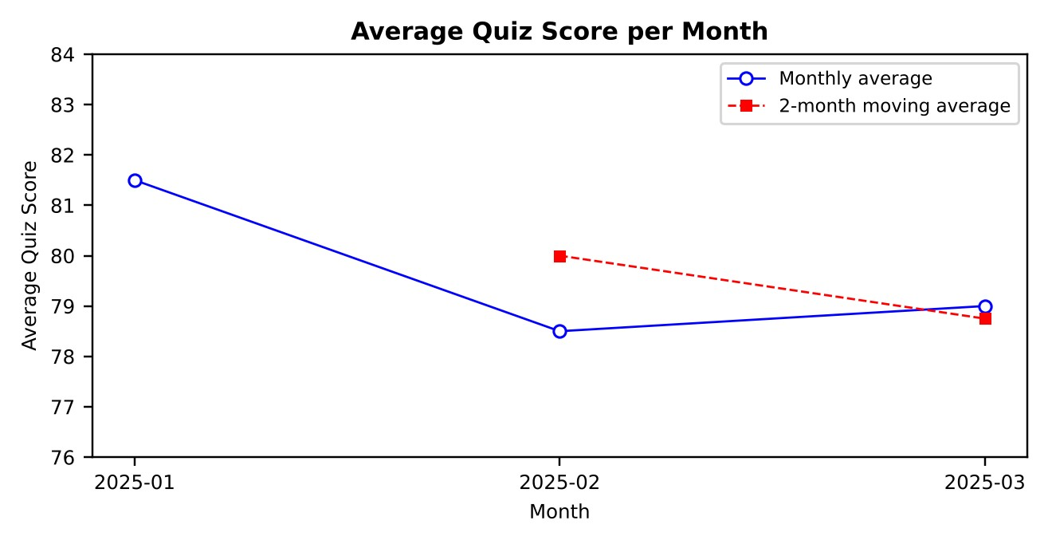
Output 5: Average Quiz Score per Month with Moving Average
Trend: The average quiz score falls from 81.50 in January to 78.50 in February and recovers slightly to 79.00 in March. The moving average declines from 80.00 to 78.75, so the overall trend is a small downward movement of about 2.5 points over the three months.

PROGRAM 4: Tableau Dashboard for Online Learning Activity
Import Online_Learning_Activity.csv into Tableau. Create a bar chart showing average quiz score by course, a scatter plot (Study Time vs Quiz Score), and add a filter for Gender and Course. Design a mini interactive dashboard.
Steps in Tableau:
- Open Tableau, choose Connect > Text file, and load Online_Learning_Activity.csv. Make sureLogin_Date is set to the Date data type.
- Sheet 1 (Bar Chart): drag Course to Columns and Quiz Score to Rows, and change the aggregationto AVG. Choose the Bar mark type, drag Course to Color, and title the sheet "Average Quiz Score by Course".
- Sheet 2 (Scatter Plot): drag Study Time to Columns and Quiz Score to Rows. Drag Student ID to
Detail so that each student is shown as a point, and drag Course to Color. Title the sheet "Study Time vs Quiz Score".
- Right-click Gender in the Data pane and choose Show Filter. Do the same for Course. For eachfilter, choose Apply to Worksheets > Selected Worksheets and select both sheets.
- Create a new Dashboard, drag Sheet 1 and Sheet 2 onto it, and arrange them side by side with theGender and Course filters at the right.
- For interactivity, select "Use as Filter" on the bar chart so that clicking a course updates the scatterplot.
- Title the dashboard "Online Learning Dashboard" and save the workbook.
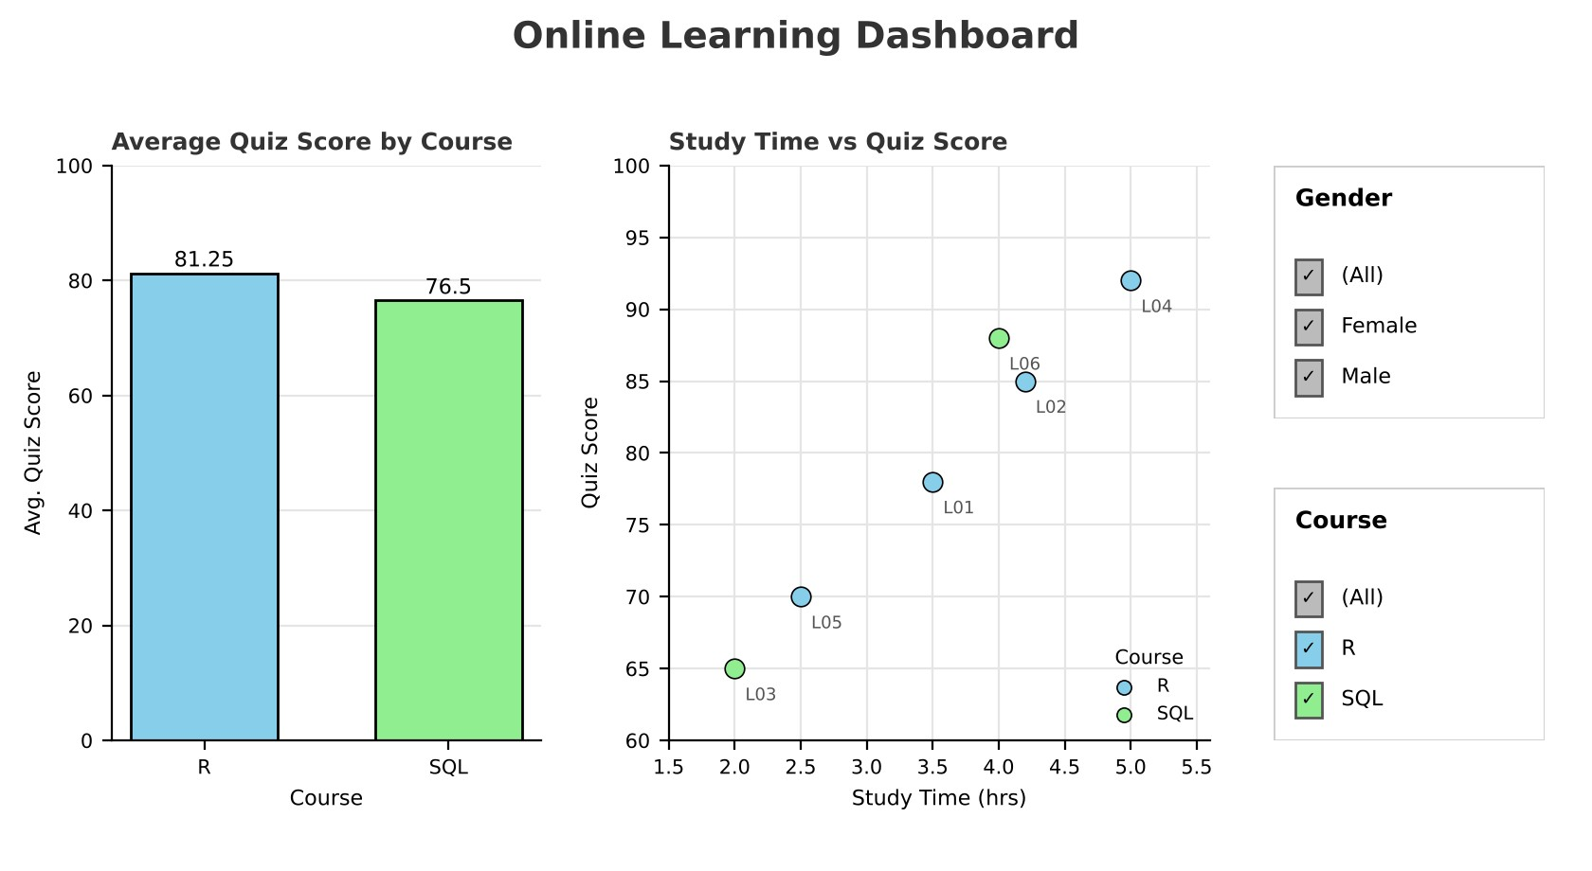

Output 6: Online Learning Activity Tableau Dashboard
Observation: The dashboard shows the average quiz score for each course next to the study time and score of every student. Changing the Gender or Course filter, or clicking a bar, updates both views, so users can explore the learning activity interactively.

Set 9 Procedure
- Import the dataset with read.csv() and view its columns.
- Use hist() for the histogram and boxplot() with a formula (Quiz_Score ~ Course) for the boxplot bycourse.
- Use ggplot() with geom_point(alpha = 0.6) and size = Videos_Watched for the bubble scatter plot,and cor() to measure the relationship.
- Convert Login_Date with as.Date(), find the monthly average with aggregate(), smooth it withstats::filter(), and draw the line chart with plot() and lines().
- Import the CSV file in Tableau, build the bar chart and scatter plot, add Gender and Course filters,and combine them in a dashboard.

Set 9 Result
The online learning activity data was successfully analysed in R using a histogram, boxplot, bubble scatter plot, and a monthly average line chart with moving average smoothing. A Tableau dashboard with a bar chart, a scatter plot, and Gender and Course filters was created for interactive exploration.

Key Functions Used
Function / Tool | Purpose
read.csv() | Imports the dataset from the CSV file.
hist() / boxplot() | Create the histogram and the boxplot by course.
ggplot() + geom_point() | Creates the bubble scatter plot with transparency.
cor() | Calculates the correlation coefficient.
as.Date() / format() | Convert Login_Date and extract the month.
aggregate() | Calculates the average quiz score per month.
stats::filter() | Calculates the moving average.
Tableau Dashboard | Combines sheets with filters for interactive exploration.

